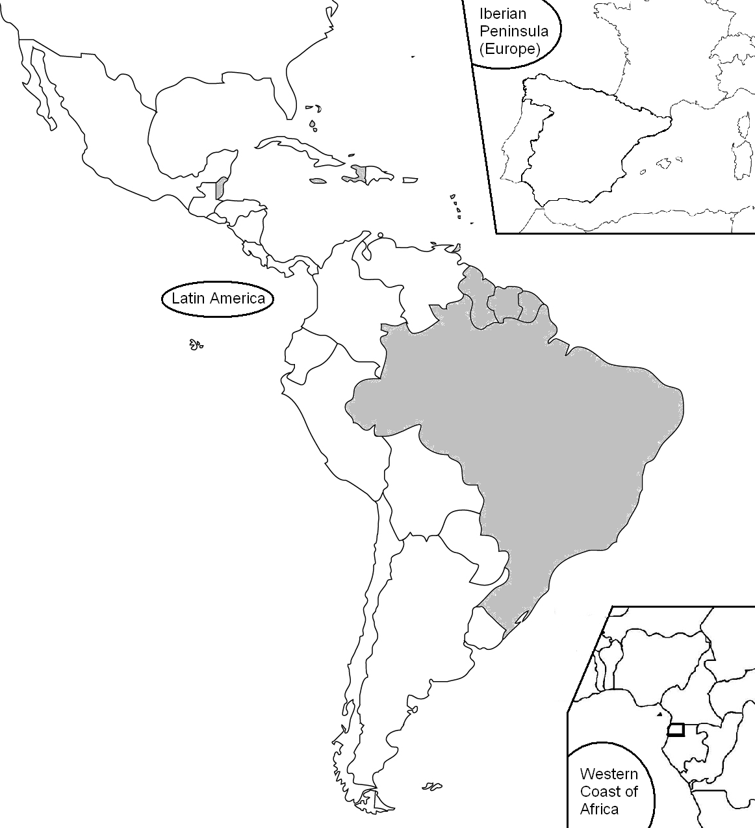
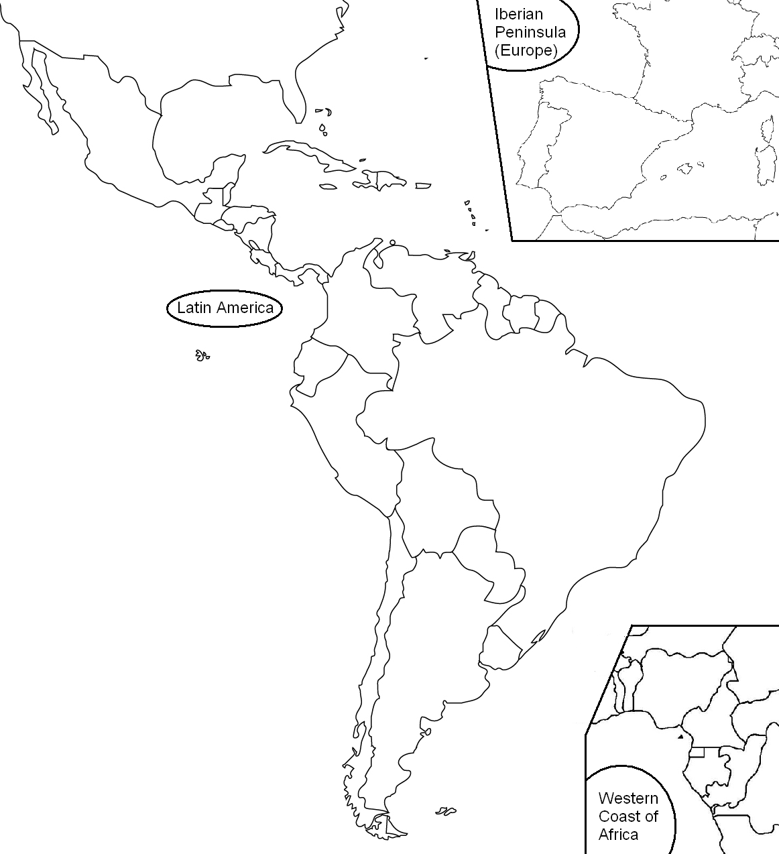

1.

Label all 22 countries where Spanish
is spoken. Remember to write the
names and capitals in Spanish and
include accents if needed.
1. _España______________________
2. _______________________________
3. _______________________________
4. _______________________________
5. _______________________________
6. _______________________________
7. _______________________________
8. _______________________________
9. _______________________________
10. ______________________________
11. ______________________________
12. ______________________________
13. ______________________________
14. ______________________________
15. ______________________________ 19. ______________________________
16. ______________________________ 20. ______________________________
17. ______________________________ 21. ______________________________
18. ______________________________ 22. ______________________________
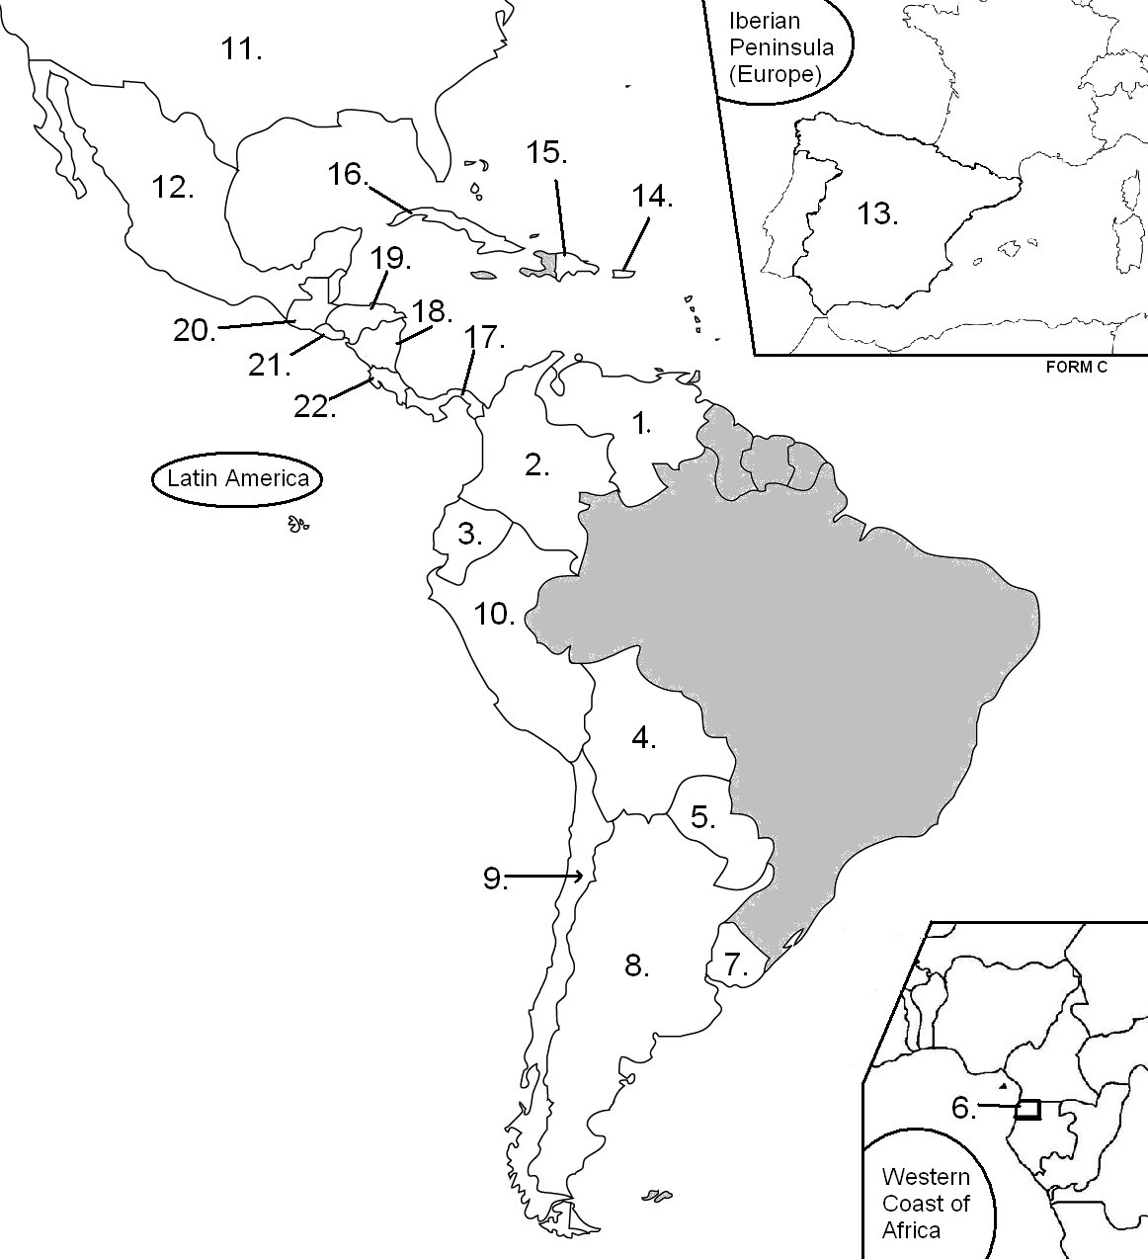

Label all 22 countries where Spanish
is spoken. Remember to write the
names in Spanish and include accents
if needed. Don’t forget the capitals too!
1. _______________________________
2. _______________________________
3. _______________________________
4. _______________________________
5. _______________________________
6. _______________________________
7. _______________________________
8. _______________________________
9. _______________________________
10. ______________________________
11. ______________________________
12. ______________________________
13. ______________________________
14. ______________________________
15. ______________________________ 19. ______________________________
16. ______________________________ 20. ______________________________
17. ______________________________ 21. ______________________________
18. ______________________________ 22. ______________________________

